Name: Poorab Gangwani

Section: 2B

Enrollment #: CS191092

**LAB # 7**

**Uncontrolled Half-Wave Rectifier**

**Lab Objectives:**

* To study the characteristics and operation of half-wave rectifiers
* To study the effect of smoothing capacitors on the output of rectifiers.
* To find out ripple factor of half-wave rectifier

**Apparatus Required:**

* Function Generator
* Diodes
* Capacitor
* Resistors
* Oscilloscope
* Connecting wires
* Bread Board

**PRE-LAB**

**Rectification:**

Rectification is the process of converting Alternating Current (AC) into Direct Current (DC). AC current and voltage change to positive and negative polarities alternately (bidirectional), while DC current and voltage only has either one polarity (unidirectional). The electrical devices used to perform rectification are called Rectifiers.

The electricity being supplied to the consumers is an alternating voltage. Electronic devices such as TV, computers and mobile phones need DC voltage to work. Therefore, rectifiers are used. Fig. 7.1 shows the waveform of an AC voltage.

It has an average value of zero since its one half-cycle is similar, but opposite to its other half cycle.

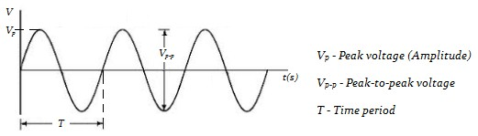

*Fig 7.1: Sinusoidal*

*Waveform of an AC*

*Voltage*

**Half-Wave Rectification:**

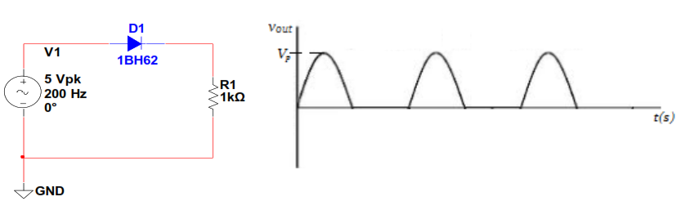If the sinusoidal AC voltage is supplied to a half-wave rectifier circuit, as shown in Fig. 7.2, then assuming an ideal diode, the diode will be conducting during the positive half-cycle of the input voltage and show a voltage drop across the load resistor equal to the input voltage. The diode will be reverse biased during the negative half-cycle of the input voltage and act as an open circuit. The voltage across the resistor will be zero during this time.

*Fig. 7.2: Half-wave rectifier circuit Fig. 7.3: Output voltage of a half-wave rectifier*

Only the positive half-cycle of the input voltage will appear across the resistor. Such a waveform is called a half wave waveform.

Dc voltage is the average value of the half-wave signal, which is given by,

$V_{AVG}= \frac{V_{P}}{π}$**eq. 7.1**

The frequency of the output voltage is the same as that of the input voltage, since the time period for each cycle of the output waveform is equal to that of the input voltage waveform

**Ripple Factor:**

The ripple factor (r) is an indication of the effectiveness of the filter and is defined as

$r=\frac{Vr (pp)}{VDC}$ eq. 7.2

In other words, it is a measure of the quality of the rectification of an AC current.

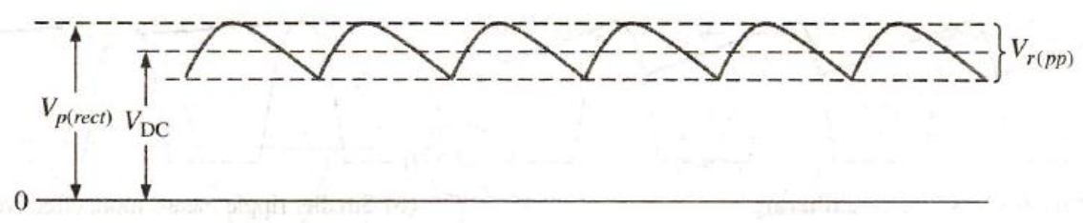

*Fig. 7.4: Ripple voltage*

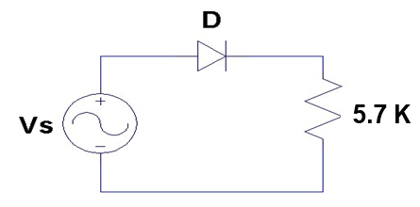**IN-LAB**

*Fig 7.5: lab task 1*

**LAB TASK 1:**

* Develop the circuit of **fig. 7.5** on breadboard.
* Supply Sine wave signal from function generator having amplitude **20Vp-p** and frequency **50 Hz** at the input of circuit.
* Connect the oscilloscope across the load resistor (R=5.7k) and record Vrpp and Vavg in **table 7.1**
* Now connect capacitor one by one of different values parallel with the load resistor and fill up **table 7.1.**
* Calculate the ripple factor using **eq. 7.2**

|  |  |  |  |
| --- | --- | --- | --- |
| **Capacitor**  **(µF)** | **Peak to Peak**  **Ripple**  **Voltage**  **Vr(pp)** | **DC average Voltage**  **(Vavg)** | **Ripple Factor**  **(r)** |
| Without Capacitor | **0.197** | **0.062** | **3.177** |
| 10 | **4.933** | **1.570** | **3.142** |
| 33 | **1.724** | **0.549** | **3.140** |
| 47 | **1.272** | **0.404** | **3.148** |
| 100 | **0.581** | **0.184** | **3.157** |

*Table 7.1: lab task 1*

**LAB TASK 2:**

* Develop the circuit of **fig. 7.5** on breadboard.
* Supply Sine wave signal from function generator having amplitude **10Vp-p** and frequency **100 Hz** at the input of circuit.
* Connect the oscilloscope across the load resistor (R=5.7k) and record Vrpp and Vavg in **table 7.2**
* Now connect capacitor one by one of different values parallel with the load resistor and fill up **table 7.2.**
* Calculate the ripple factor using **eq. 7.2**

|  |  |  |  |
| --- | --- | --- | --- |
| **Capacitor**  **(µF)** | **Peak to Peak**  **Ripple**  **Voltage**  **Vr(pp)** | **DC average Voltage**  **(Vavg)** | **Ripple**  **Factor**  **(r)** |
| Without Capacitor | **9.334** | **2.972** | **3.140** |
| 10 | **1.319** | **0.419** | **3.147** |
| 33 | **0.434** | **0.138** | **3.144** |
| 47 | **0.303** | **0.096** | **3.156** |
| 100 | **0.216** | **0.040** | **3.15** |

*Table 7.2: lab task 2*

**Conclusion:**

**__________________________________________________________________**

**__________________________________________________________________**

**__________________________________________________________________**

Name: Poorab Gangwani

Enrollment #: CS191092

**POST-LAB ASSIGNMENT # 7**

Q.1) What is the conduction period (in degrees) of diode during ‘Half-Wave Rectification’?

180 degrees

Q.2) What is the Peak Inverse Voltage?

Ans) It is the maximum voltage a diode can withstand in the reverse-biased direction before breakdown.

Q.3) If the ac supply is 60 Hz, what will be the ripple frequency of the half-wave rectifier?

_____________60hz______________________________________________________________